“we spring from the passions” (front). Collage – Ru Wen.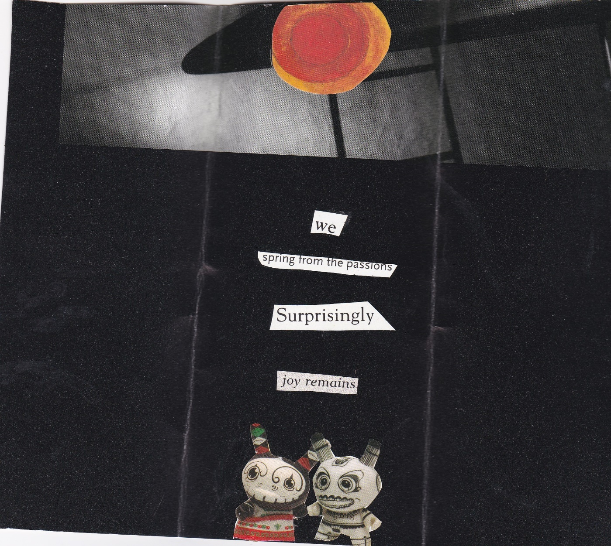

“we spring from the passions” (back). Collage: Ru Wen
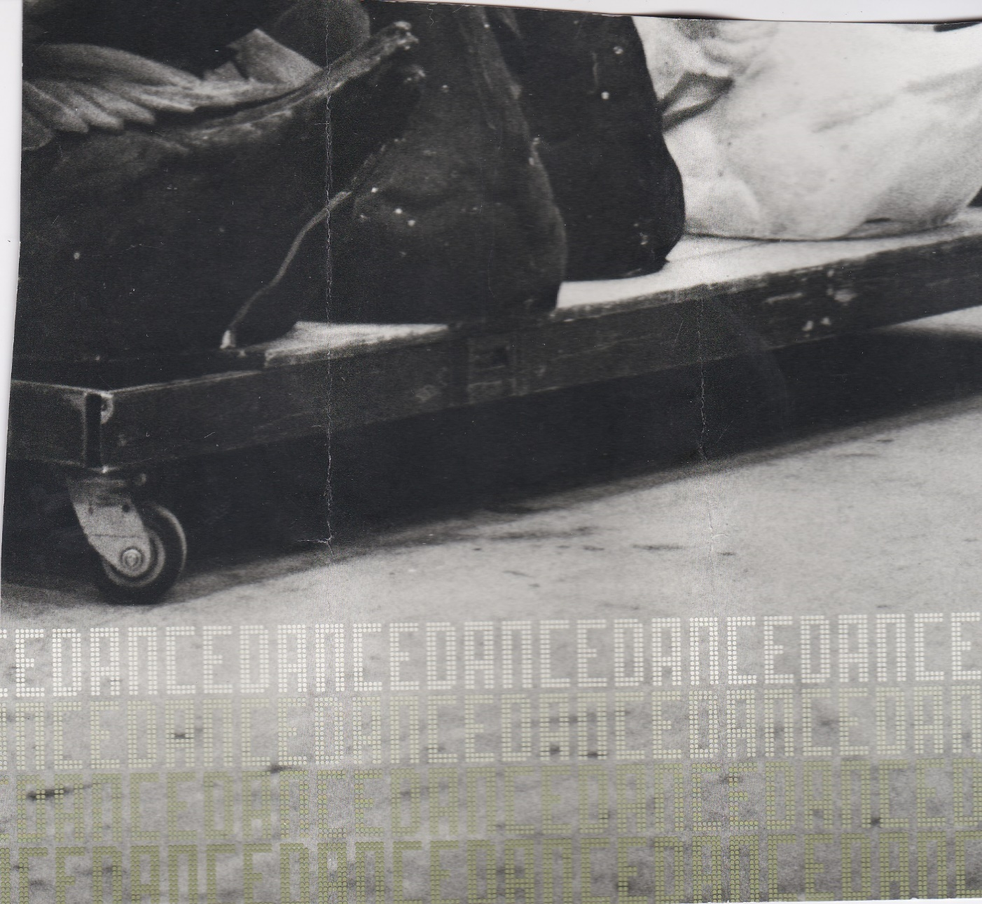

“the humming eye of earth”(front). Collage: Ru Wen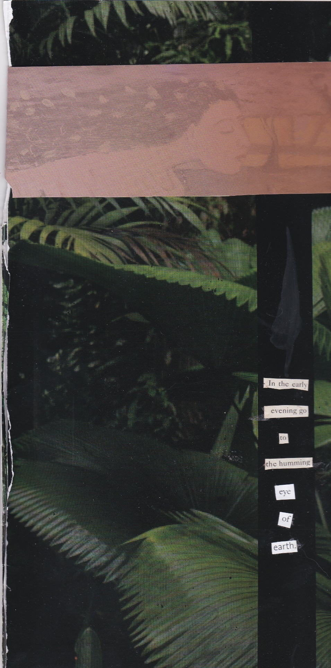
“the humming eye of earth” (back). Collage: Ru Wen
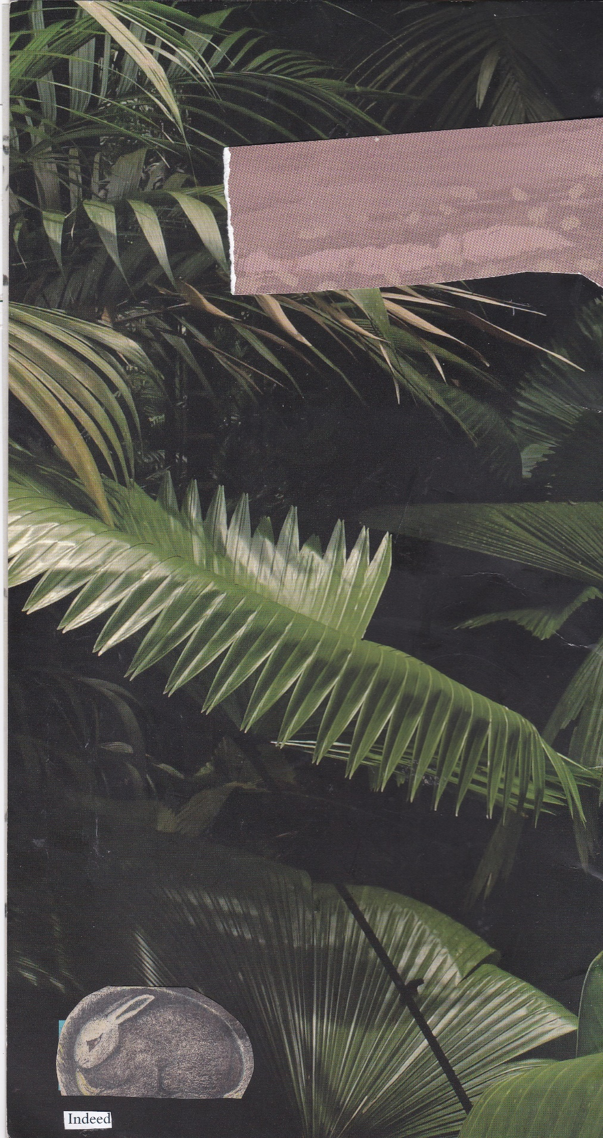
“free admission to all wonders”. Collage: Ru Wen

